Easy A: Calculate the volume of the following ______________

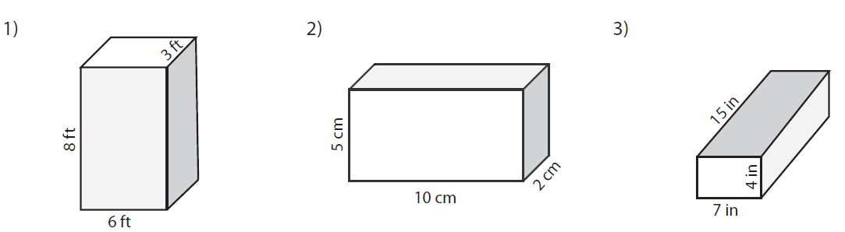

Easy B: Calculate the volume of the following _____________________________

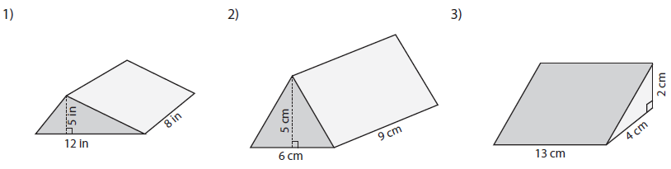

Medium A: Calculate the volume of the following ______________________ (round answers to the nearest whole number)

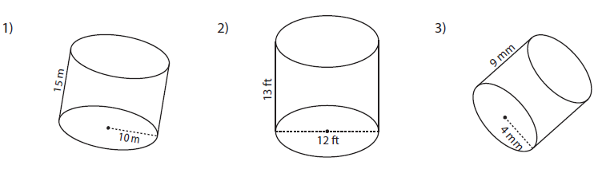

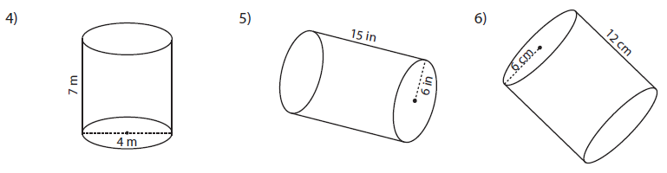

Medium A: Calculate the volume of the following ______________________ (round answers to the nearest whole number)

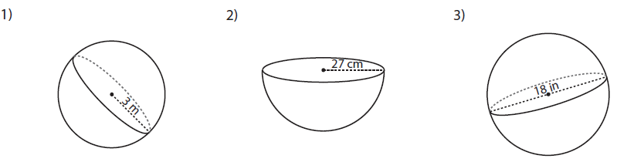

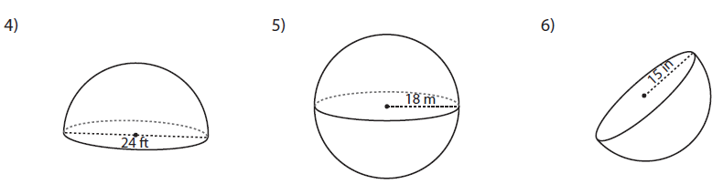

Challenging A: Calculate the volume of the following ______________________ (round answers to the nearest whole number)

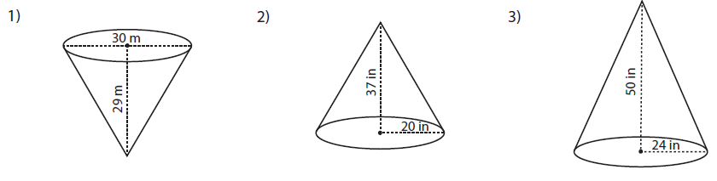

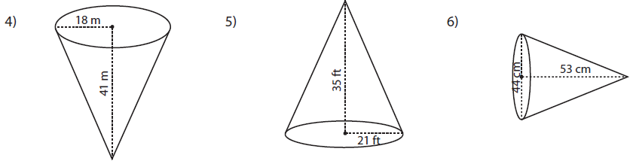

Challenging B: Calculate the volume of the following ______________________ (round answers to the nearest whole number)

1. The formula to calculate the volume of a cone is 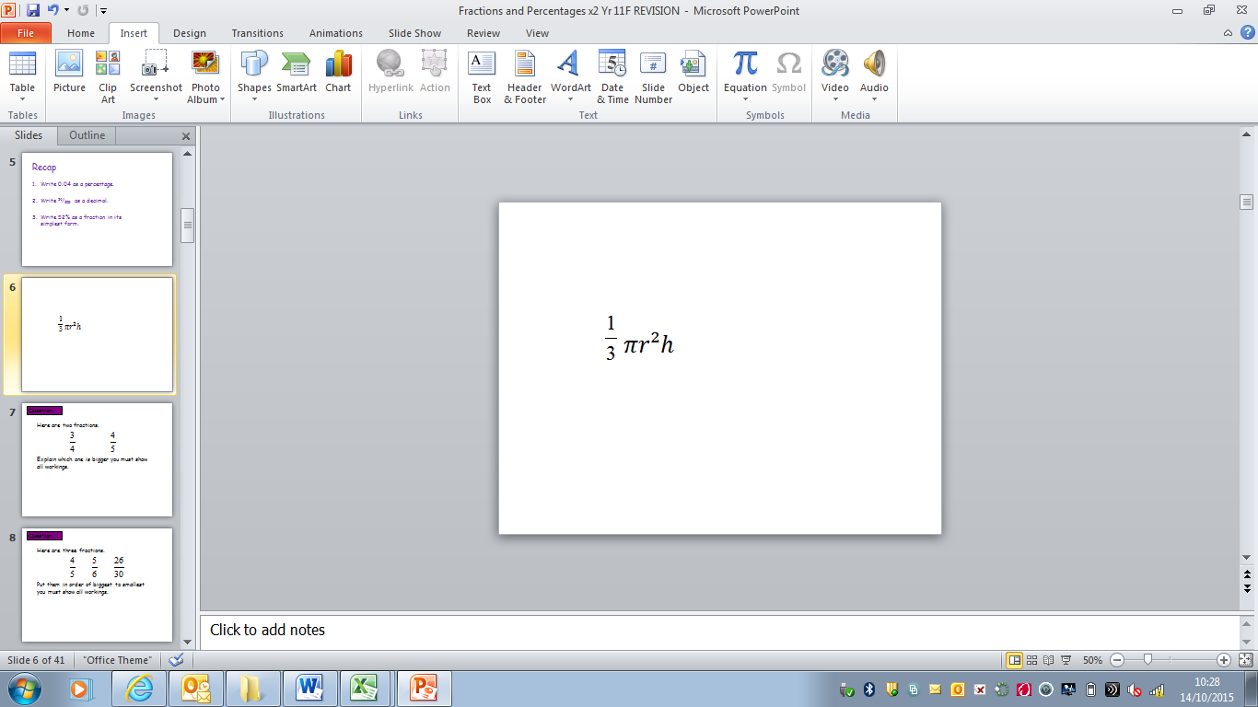. This cone has been cut into 2 pieces. Find the volume of part B.
2. 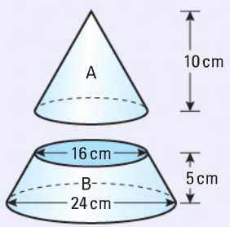 b) 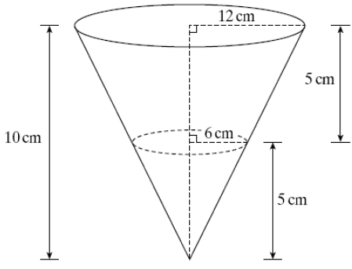

Red: Calculate the Surface Area of the following shapes

